Delivering My Baby and Me/Rhyme Bags
through distance learning
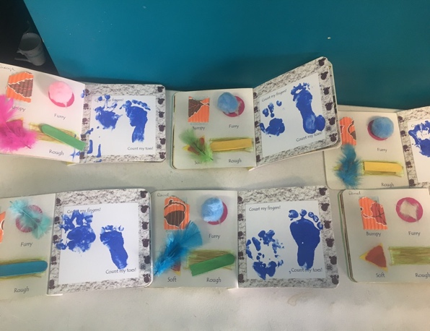

Platform: WhatsApp

The objective of the WhatsApp group is to keep a line of communication open between tutor and learners, while delivering course content and equipping them with simple activities, while also maintaining conversation on the themes we would have explored during class time.

No of Learner: 8

Tutor: Tracey Daly

Duration 2 hours per week

Group Profile: All learners have babies between 6-12 months, most have a toddler or pre-schooler also. It is very important to tailor information to suit both age groups.
Classes have had to stop due to Covid 19 and I continue to ‘meet’ the group using mobile phone technology using WhatsApp.
The general consensus is that all learners miss attending and seeing each other, they have highlighted how the books they received during ‘My Baby and Me’ have been used quite a lot in each household and they are very grateful to have these resources at this time.
I try to keep the activities I upload as simple as possible, so parents don’t get overwhelmed, I have been concentrating on sensory activities. Parents seem to respond best to these.

Examples: of some rhymes, activities and stories shared on the group WhatsApp

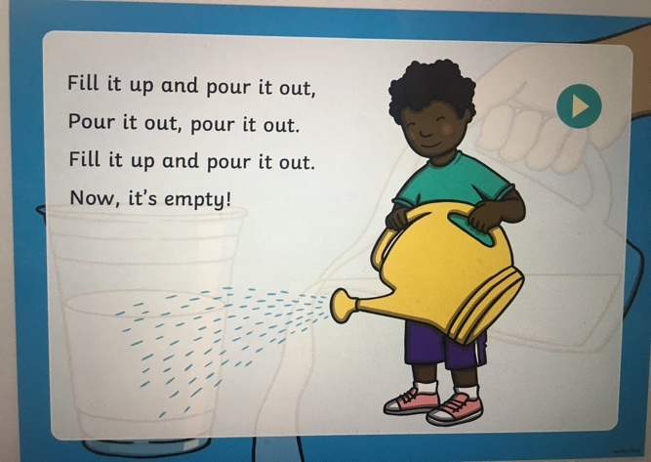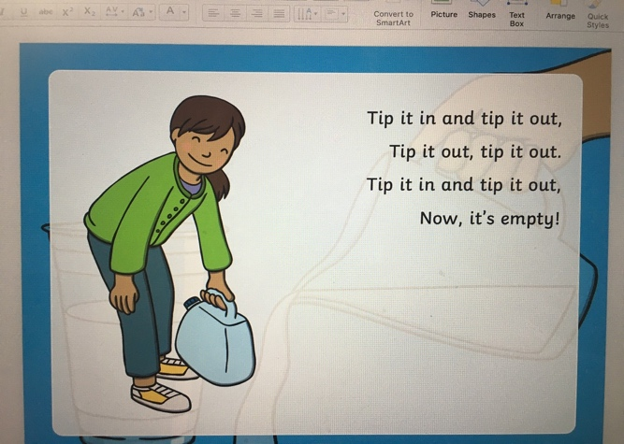
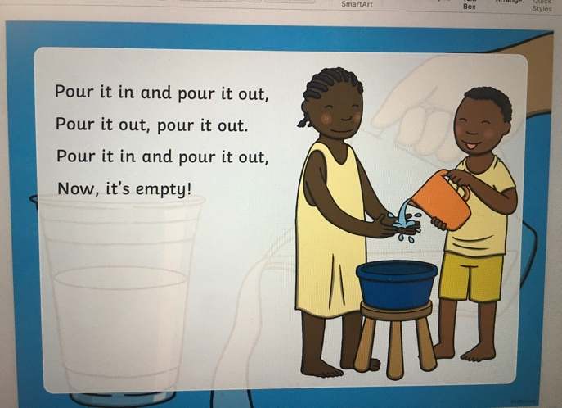

This simple activity is done to the tune of London bridge and promotes the understanding of capacity www.twinkl.ie
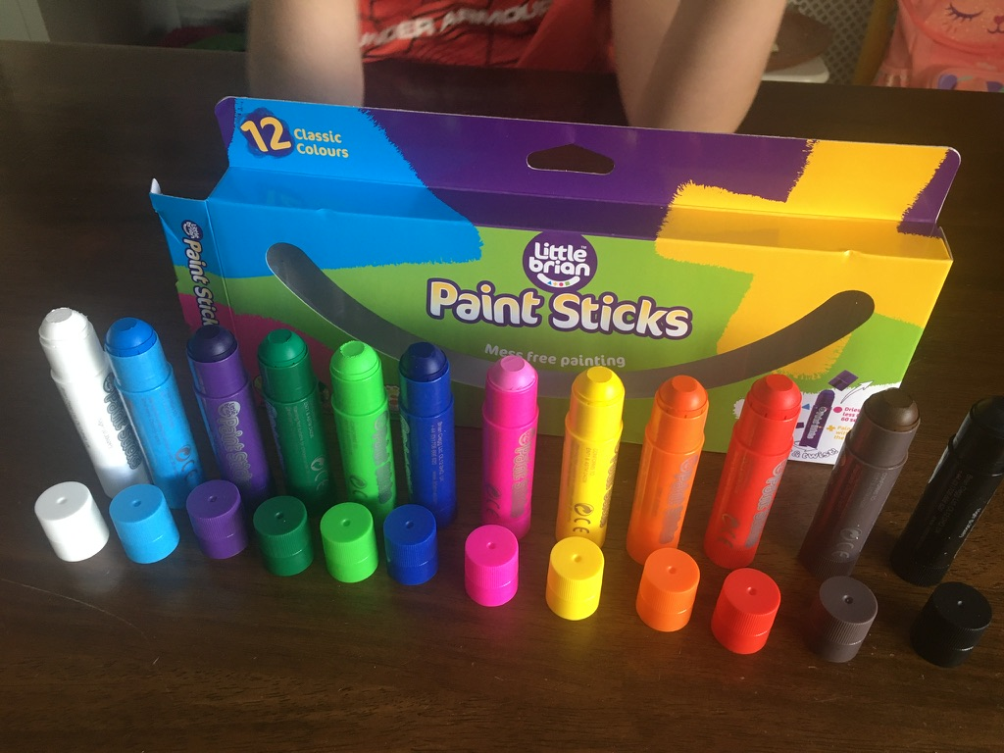

These mess free paint sticks are great for smaller children

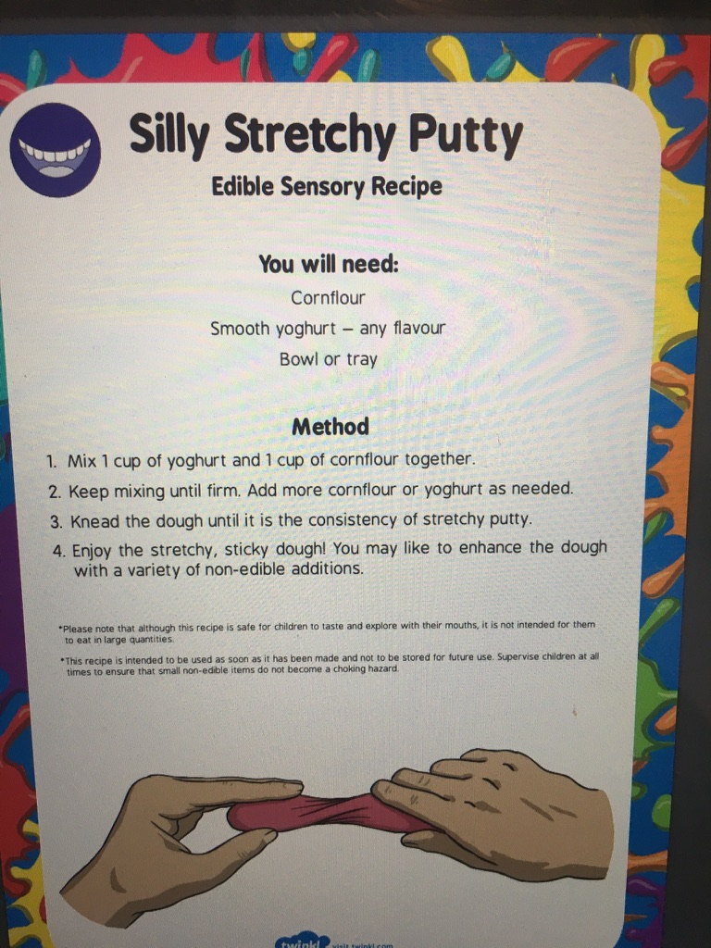

Messy Play
Parents voiced concern over using play doh, this is a good edible alternative (twinkl)

Covid Time Capsule: I sent the covid capsule PDF to parents (please find PDF attached)

How to make a time capsule to remember this unprecedented time

Some potential items to include:
- Anti bacterial wipe packet
- A couple of squares of toilet paper
- List of the shows you binge-watched on Netflix
- Recipe for a dish you made
- Evidence of games or activities you did as a family
- Handprint tracing of everyone in the family
- Description of the craziest or most out-of-the-box game or activity you created together
- The number of times you read a favourite book to your baby or child
- A letter to your baby describing how you’re feeling and what life is like during lockdown.

Easter Story

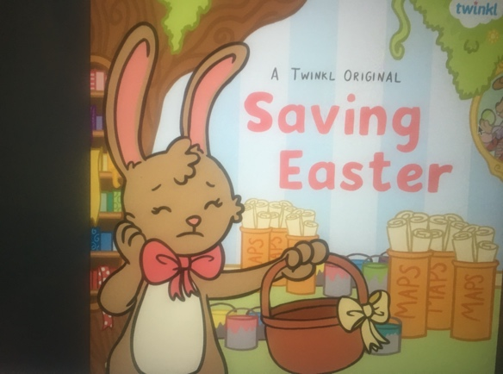

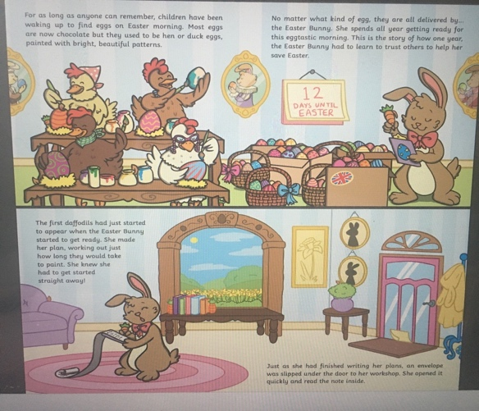

www.twinkl.ie

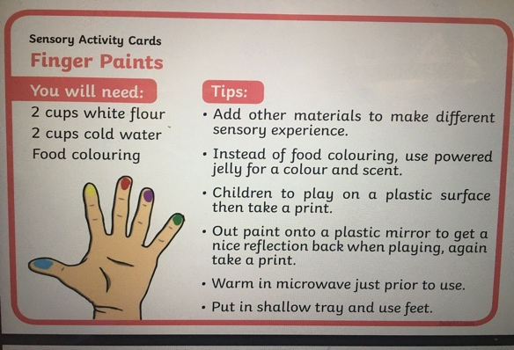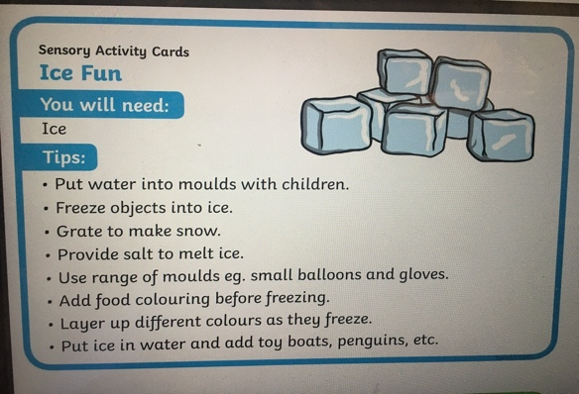
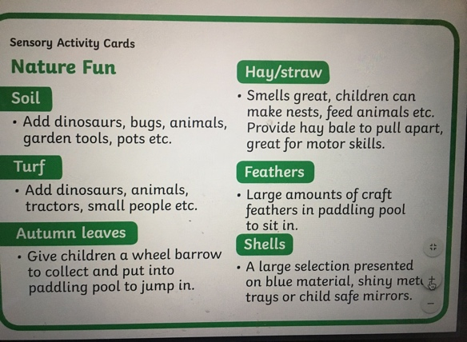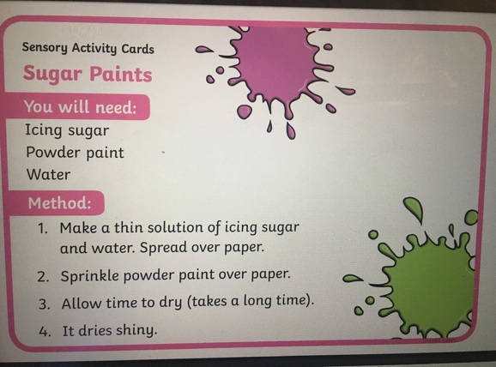

Simple sensory activities

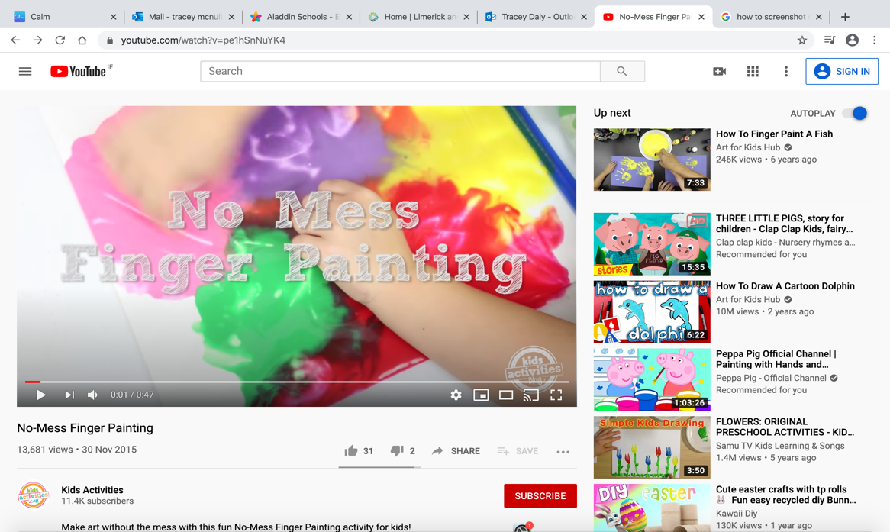

https://www.youtube.com/watch?v=pe1hSnNuYK4
The Calm Mindfulness and Meditation App has some beautifully told sleep stories for kids, this is a great way to relax the mind during these stressful times.

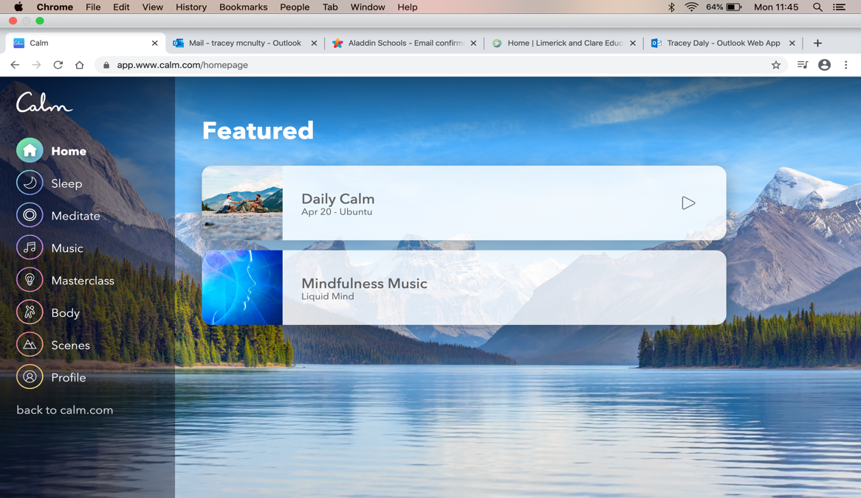

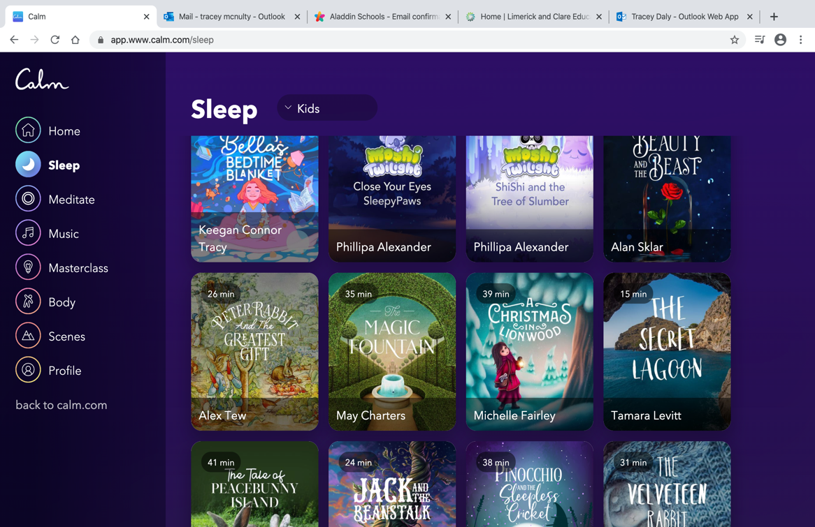

https://app.www.calm.com/homepage

Oxford owl has a large range of ebooks that are tablet friendly that parents and children can access from home for free.

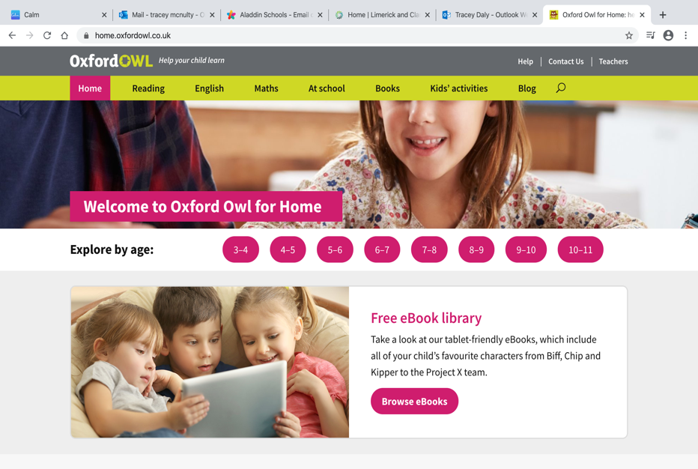

https://home.oxfordowl.co.uk/

